
Name:

11 Physics
Waves and Atomic
Physics
Topic Test 2015

Score: _________ / 93 ______________%

TIME ALLOWED FOR THIS TEST
Working time for this paper: 1 hour and 40 minutes

MATERIAL REQUIRED OR RECOMMENDED FOR THIS TEST

This question and answer booklet
Physics Formula & Constants Sheet
Pens, pencils, eraser, rule, Mathaid or Math-o-Matt
Scientific calculator

INSTRUCTIONS
Answer all questions and write answers in the spaces provided.
Numerical answers should be evaluated with three significant figures unless otherwise stated and given in scientific notation.

1. Complete the following decay equations by replacing :

a. 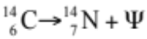 (1 mark)

b. 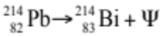 (1 mark)

c. 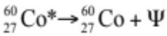 (1 mark)

2. When bombarded with neutrons, gold (Au-197) undergoes neutron absorption to become the radioactive isotope gold-198. Given that gold has an atomic number of 79, write a balanced equation for:
a. the absorption of a neutron by a gold-197 atom (2 marks)

b. the beta decay of a radioactive nucleus of gold-198. (2 marks)

3. Cobalt-60 has a half-life of 5.3 years. A sample of pure cobalt-60 has a mass of 50 µg. How much of the Co-60 remains after:
a. 10.6 years? (2 marks)

b. 15.9 years? (2 marks)

c. 21.2 years? (3 marks)

4. Why is alpha radiation not used as a source in external radiotherapy treatment?
(2 marks)

5. A 78 kg man is exposed to 200 mJ of gamma radiation. Calculate:
a. his absorbed dose (1 mark)

b. his dose equivalent (1 mark)

c. his dose equivalent if he had been exposed to 200 mJ of alpha radiation instead (1 mark)

d. the energy of the radiation in electronvolts (eV). (1 mark)

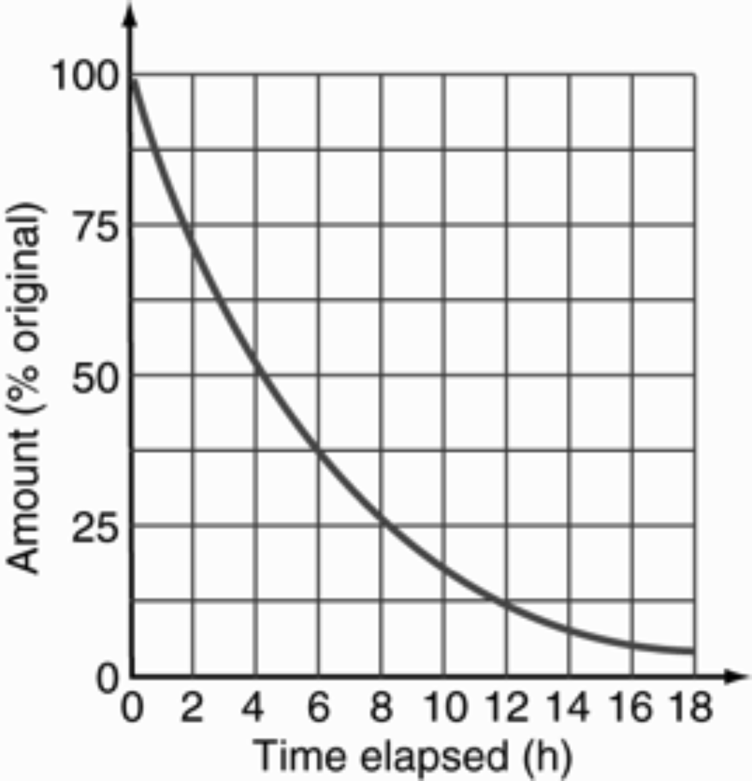
6. The radioactive decay of a particular isotope is shown on the graph below. The initial mass of the radioisotope is 20 g.

a. Find the time it takes for a 20 g sample to decay to 5.0 g. (2 marks)

b. Find the half-life of the sample. (1 marks)

c. How much of the original radioisotope (in grams) remains after 6.0 hours?
(2 marks)

d. Calculate the amount of the radioisotope remaining (in grams) after 20 hours have elapsed.
(2 marks)

7. a. Balance the following equation by replacing A and Z. 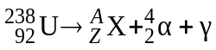
(2 marks)

b. How does the combined mass of the products compare with the mass of the U-238 nucleus? (1 mark)

8. Consider the fission reaction below:

a. Determine the identity of the missing item X.
(2 marks)

b. Convert the energy released into joules. (1 mark)

c. How much mass was converted to energy in the reaction? (2 marks)

d. Using the fact that 1.00 kg of uranium-235 contains 2.5 × 10²⁴ nuclei, how much energy would be released if all the nuclei in 1.00 kg of uranium-235 underwent fission? (2 marks)

9. The following is a diagram of a thermal nuclear power station.
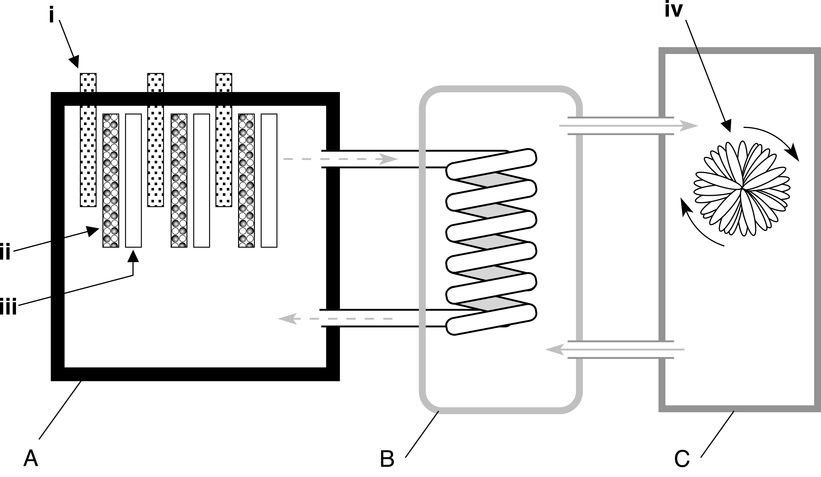

a. Name the parts labelled i, ii, iii and iv. (4 marks)

b. Name and describe the function of the sections labelled A, B and C.
(6 marks)

10. Explain why a chain reaction does not occur in the uranium ore that is dug up from a uranium mine. (2 marks)

11. A particular nuclear reactor generates about 1200 MW of electrical power, but operates at about 25% efficiency; i.e. only 25% of the thermal energy is transformed into electrical energy.

a. How much electrical energy is generated each day? (2 marks)

b. Assuming that this energy has been transformed from uranium-235, how much uranium-235 (in grams) is consumed each day by this plant?
(2 marks)

c. How much energy is converted into electrical energy? (1 mark)

12. One of the reactions taking place in a fusion reactor is shown below:
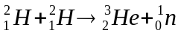
a. How many neutrons are released during this fusion reaction? (1 mark)

b. How does the combined mass of the reactants compare with the combined mass of the products in this fusion reaction? (2 marks)

c. About 15 MeV of energy is released during this fusion reaction. How much energy is this in joules? (2 marks)

13. One of the fusion reactions taking place inside the Sun is shown below:
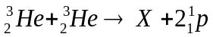
a. Identify the missing nuclide X. (2 marks)

b. If 4.0×10⁻¹² J of energy is released during this fusion reaction, how much is released in electronvolts? (1 mark)

14.
- Sketch a displacement versus distance graph representing the movement of the particles with the following properties: Wavelength = 0.2 m, amplitude = 0.05 m.
(2 marks)

- Use a dot to indicate the location of the particle on the graph at a distance of 0.1 m from the origin. If the wave is travelling to the right, use an arrow to indicate the direction (up or down) this particle is moving at the time shown. (1 mark)

15. Explain the difference between a longitudinal wave and a transverse wave. Give an
example of each. (4 marks)

16. With reference to waves, define the term ‘destructive interference’. Use an example to support your definition. (2 marks)

17.
- Determine the period of the wave responsible for the motion of the particle depicted on the graph below. (1 mark)

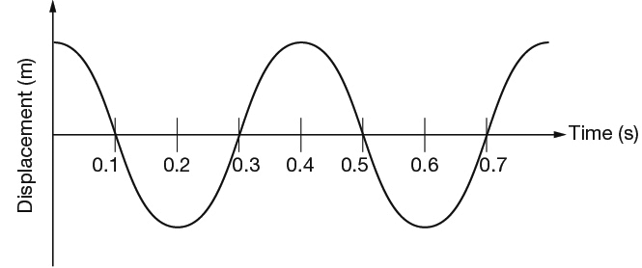

b Calculate the speed of the wave if the wave moves 2 m in the time for one period.
(1 mark)

18. Your friend wants to install a mirror on the wall in their house. You are told that when they are standing their eyes are 1.5 m directly above their toes. Use the law of reflection to determine how far the bottom of the mirror has to be off the ground so your friend can see their shoes in the mirror. (2 marks)

19. A wave was observed crossing the boundary between two mediums. The wave travelled the same distance in in each medium but took more time to travel this distance in the second medium compared to the first.

Compare the properties of the wave before and after it crossed the boundary between the two mediums. (2 marks)

20. A friend sits stationary on a swing and asks you to push them. Explain how the concept of resonance relates to pushing your friend so their height of swing increases over time.
(2 marks)

21. Outline the conditions that must be met for a standing wave to be produced.
(3 marks)

22. Two pulses on a string approach each other as shown below.

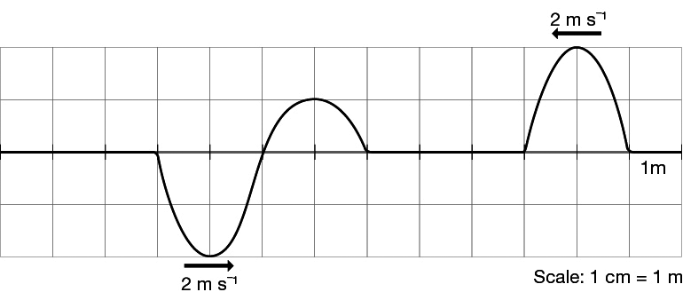

- On the grid below, draw in one colour the positions of the two individual pulses 2 seconds after their positions shown in the diagram above. (2 marks)

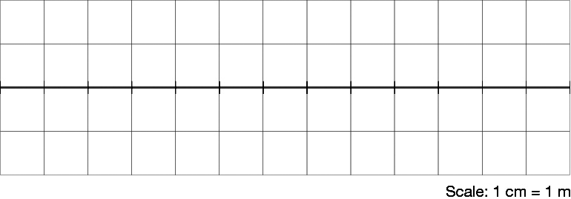

- Then draw in another colour the superposition of the two pulses at this time.
(1 mark)

23. A guitar string is held stationary at a point along the neck of the guitar by pressing a finger on it. This finger is 0.5 m from the fixed end of the string and the string is plucked somewhere along this 0.5 m.
- Draw a diagram, showing where the displacement nodes and antinodes of the first harmonic exist on this 0.5 m of string.
(1 mark)

- Calculate the wavelength of the first harmonic standing wave produced in the string.
(1 mark)

24. A simulator of the human head is used to determine the efficiency of hearing aids. The process involves a set frequency sound being produced from a speaker at one side of the simulator as shown in the diagram. Hearing aid A is closest to the speaker and a display of its reception is given.

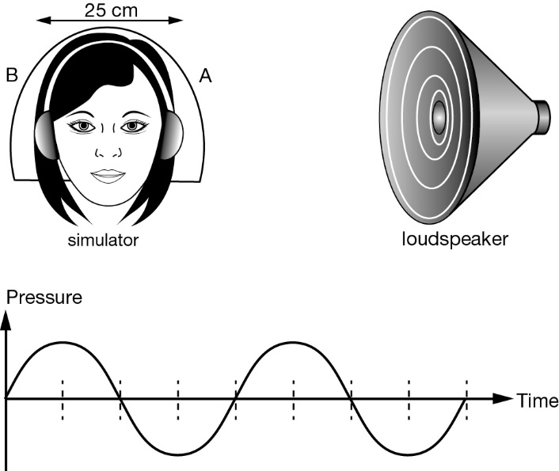

- On the same axes (above) draw the display as it will appear one-quarter of a cycle later. (2 marks)

(cont. on next page)
Hearing aid B is 25 cm further from the speaker than hearing aid A. The graph below indicates the reception from both hearing aids at the same time.

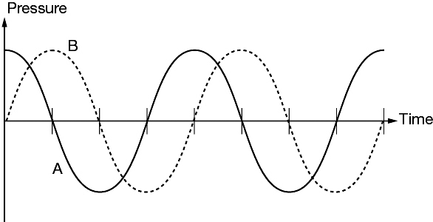

b What is the wavelength of the sound? (2 marks)

c Given the speed of sound is 340 m s^{–1}, determine the frequency of the sound.
(2 marks)

END OF TEST ☺

